**EXERCISE 1 – ANDROID APPLICATION THAT USES GUI COMPONENTS, FONT AND COLORS**

##### Aim:

To develop a Simple Android Application that uses GUI components, Font and Colors.

##### Procedure:

**Creating a New project:**

* Open Android Studio and then click on **File -> New -> New project.**

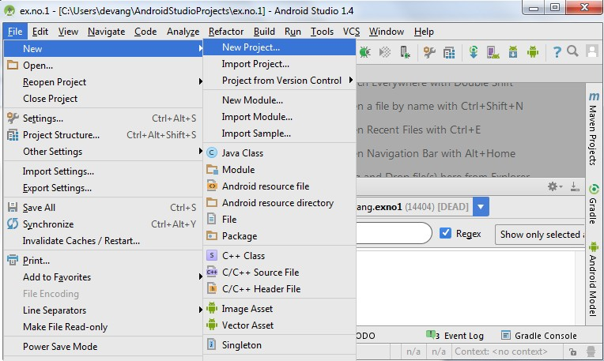

* Then type the Application name as “**ex.no.1″** and click **Next.**

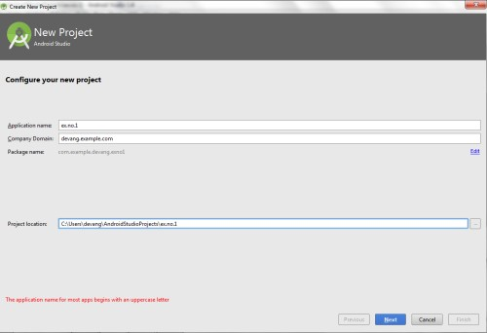

* Then select the **Minimum SDK** as shown below and click **Next**.

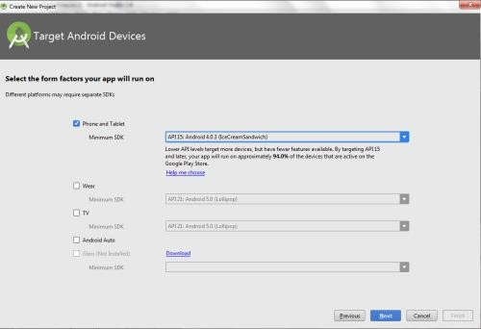

* Then select the **Empty Activity** and click **Next.**

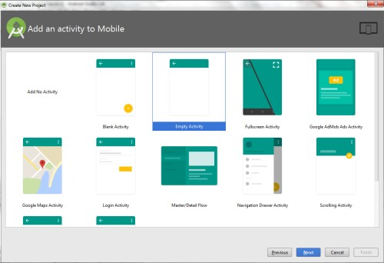

* Finally click F**inish**.

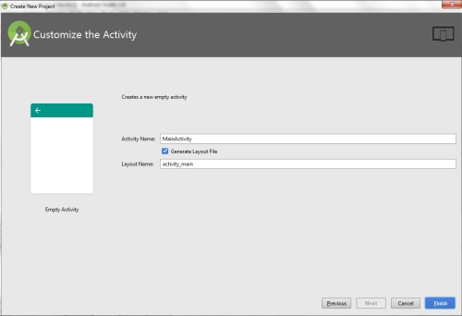

* It will take some time to build and load the project.
* After completion it will look as given below.

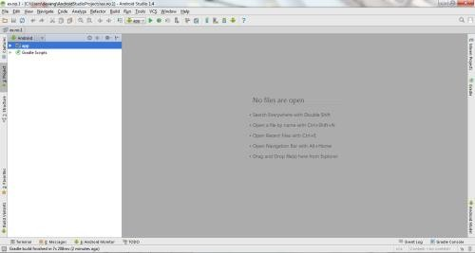

**Designing layout for the Android Application:**

* Click on **app -> res -> layout -> activity_main.xml.**

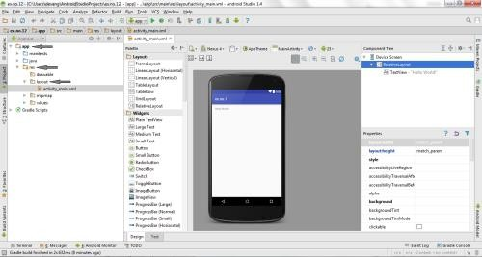

* Now click on **Text** as shown below.

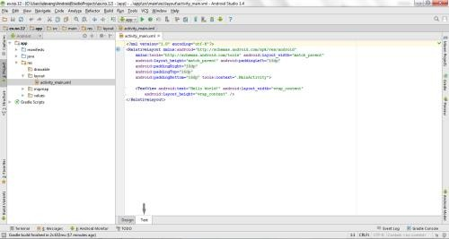

* Then delete the code which is there and type the code as given below.

##### Code for Activity_main.xml:

<?xml version="1.0" encoding="utf-8"?>

<LinearLayout [xmlns:android="http://schemas.android.com/apk/res/android"](http://schemas.android.com/apk/res/android) android:orientation="vertical"

android:layout_width="match_parent" android:layout_height="match_parent">

<TextView

android:id="@+id/textView" android:layout_width="match_parent" android:layout_height="wrap_content" android:layout_margin="30dp" android:gravity="center" android:text="Hello World!" android:textSize="25sp" android:textStyle="bold" />

<Button

android:id="@+id/button1" android:layout_width="match_parent" android:layout_height="wrap_content" android:layout_margin="20dp" android:gravity="center" android:text="Change font size" android:textSize="25sp" />

<Button

android:id="@+id/button2" android:layout_width="match_parent" android:layout_height="wrap_content" android:layout_margin="20dp" android:gravity="center" android:text="Change color" android:textSize="25sp" />

</LinearLayout>

* Now click on Design and your application will look as given below.

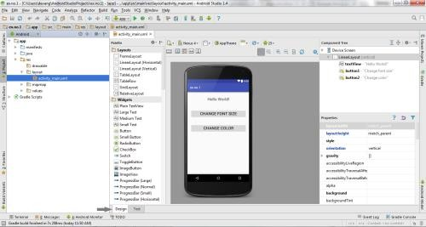

* So now the designing part is completed.

**Java Coding for the Android Application:**

* Click on **app -> java -> com.example.exno1 -> MainActivity.**

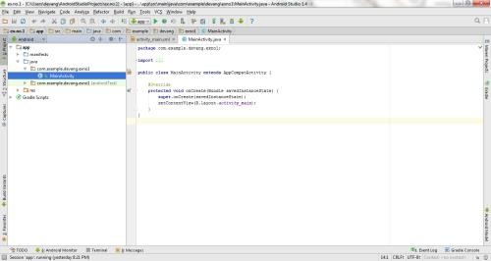

* Then delete the code which is there and type the code as given below.

##### Code for MainActivity.java:

package com.example.exno1; import android.graphics.Color;

import android.support.v7.app.AppCompatActivity; import android.os.Bundle;

import android.view.View; import android.widget.Button; import android.widget.TextView;

public class MainActivity extends AppCompatActivity

{

int ch=1; float font=30; @Override

protected void onCreate(Bundle savedInstanceState)

{

super.onCreate(savedInstanceState);

10

Android Application Development Manual

setContentView(R.layout.activity_main);

final TextView t= (TextView) findViewById(R.id.textView); Button b1= (Button) findViewById(R.id.button1); b1.setOnClickListener(new View.OnClickListener() {

@Override

public void onClick(View v) { t.setTextSize(font); font = font + 5;

if (font == 50) font = 30;

}

});

Button b2= (Button) findViewById(R.id.button2); b2.setOnClickListener(new View.OnClickListener() {

@Override

public void onClick(View v) { switch (ch) {

case 1:

t.setTextColor(Color.RED); break;

case 2:

t.setTextColor(Color.GREEN); break;

case 3:

t.setTextColor(Color.BLUE); break;

case 4:

t.setTextColor(Color.CYAN); break;

case 5:

t.setTextColor(Color.YELLOW); break;

case 6:

t.setTextColor(Color.MAGENTA); break;

}

});

}

}

}

ch++;

if (ch == 7)

ch = 1;

* So now the Coding part is also completed.
* Now run the application to see the output.

##### Output:

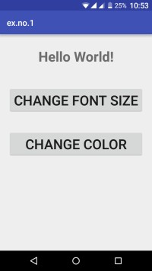 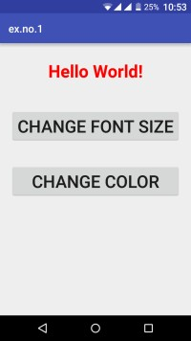 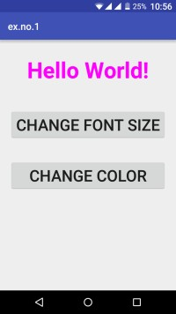

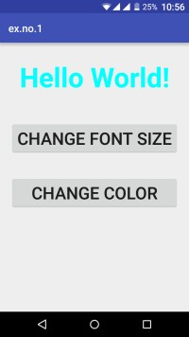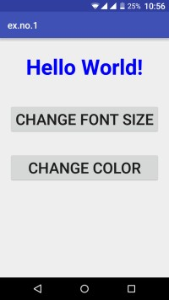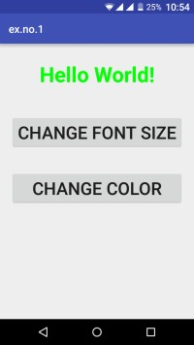

##### Result:

Thus a Simple Android Application that uses GUI components, Font and Colors is developed and executed successfully.

##### EXERCISE 1.1:

Execute the above exercise of font size and color in Android studio and show the exact GUI output? [2]

##### TASK 1.1

In the above example, Change the font styles of the text “Hello World!” by adding another button?

##### EXERCISE 1.2:

Develop an android application to display current date and time on the Button widget. [6]

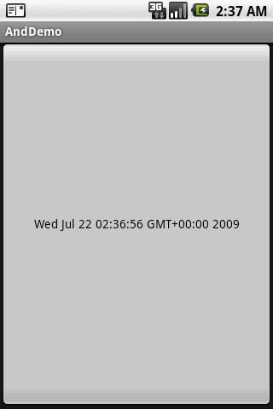

##### EXERCISE 1.3: [2]

#### Develop an android application to display the following widgets:

* 1. [Android Button](https://www.javatpoint.com/android-working-with-button)
  2. [Android Toast](https://www.javatpoint.com/android-toast-example)
  3. [Custom Toast](https://www.javatpoint.com/android-custom-toast-example)
  4. [ToggleButton](https://www.javatpoint.com/android-togglebutton-example)
  5. [CheckBox](https://www.javatpoint.com/android-checkbox-example)
  6. [AlertDialog](https://www.javatpoint.com/android-alert-dialog-example)
  7. [Spinner](https://www.javatpoint.com/android-spinner-example)
  8. [AutoCompleteTextView](https://www.javatpoint.com/android-autocompletetextview-example)
  9. [RatingBar](https://www.javatpoint.com/android-rating-bar-example)
  10. [DatePicker](https://www.javatpoint.com/android-datepicker-example)
  11. [TimePicker](https://www.javatpoint.com/android-timepicker-example)
  12. [ProgressBar](https://www.javatpoint.com/android-progressbar-example)
  13. Check Box
  14. Radio Button

##### RESOURCES:

<https://www.codingconnect.net/mobile-application-development-lab/> <https://www.javatpoint.com/android-tutorial> <https://www.tutorialspoint.com/android> <https://developer.android.com/guide> [Https://developer.Android.com/training/basics/firstapp/creating-project](https://developer.android.com/training/basics/firstapp/creating-project)

[Https://www.raywenderlich.com/120177/beginning-Android-development-tutorial-](https://www.raywenderlich.com/120177/beginning-Android-development-tutorial-installingAndroid-studio) [installingAndroid-studio](https://www.raywenderlich.com/120177/beginning-Android-development-tutorial-installingAndroid-studio) <https://www.youtube.com/playlist?list=PLS1QulWo1RIbb1cYyzZpLFCKvdYV_yJ-E> [Https://www.udemy.com/java-tutorial/](https://www.udemy.com/java-tutorial/)

[Https://www.w3schools.com/xml/](https://www.w3schools.com/xml/) [Http://www.Androidguys.com/](http://www.androidguys.com/)